|  |  |
| --- | --- |
| Course Name | ITD 2263 – Graphical User Interface Development |
| Instructor | Daniel D. Claborn |
| Student Name | Derrick McFall |
| Due date | Nov 26, 2017 11:59 PM |
| Grade | 100% |
| Grading Comments | this looks good, make sure to use the template located in the welcome section. |

Derrick McFall

Graphic User Interface

12-Nov-17

Chapter 20 #13-18

13. 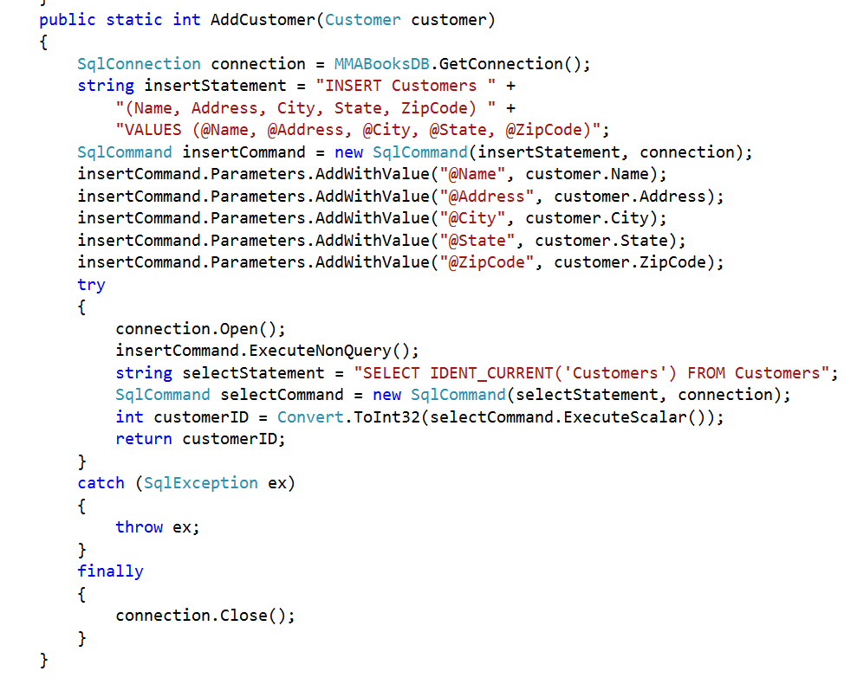

Code That I had to add:

public static int AddCustomer(Customer customer)

{

SqlConnection connection = MMABooksDB.GetConnection();

string insertStatement = "INSERT Customers " +

"(Name, Address, City, State, ZipCode) " +

"VALUES (@Name, @Address, @City, @State, @ZipCode)";

SqlCommand insertCommand = new SqlCommand(insertStatement, connection);

insertCommand.Parameters.AddWithValue("@Name", customer.Name);

insertCommand.Parameters.AddWithValue("@Address", customer.Address);

insertCommand.Parameters.AddWithValue("@City", customer.City);

insertCommand.Parameters.AddWithValue("@State", customer.State);

insertCommand.Parameters.AddWithValue("@ZipCode", customer.ZipCode);

try

{

connection.Open();

insertCommand.ExecuteNonQuery();

string selectStatement = "SELECT IDENT_CURRENT('Customers') FROM Customers";

SqlCommand selectCommand = new SqlCommand(selectStatement, connection);

int customerID = Convert.ToInt32(selectCommand.ExecuteScalar());

return customerID;

}

catch (SqlException ex)

{

throw ex;

}

finally

{

connection.Close();

}

}

14. 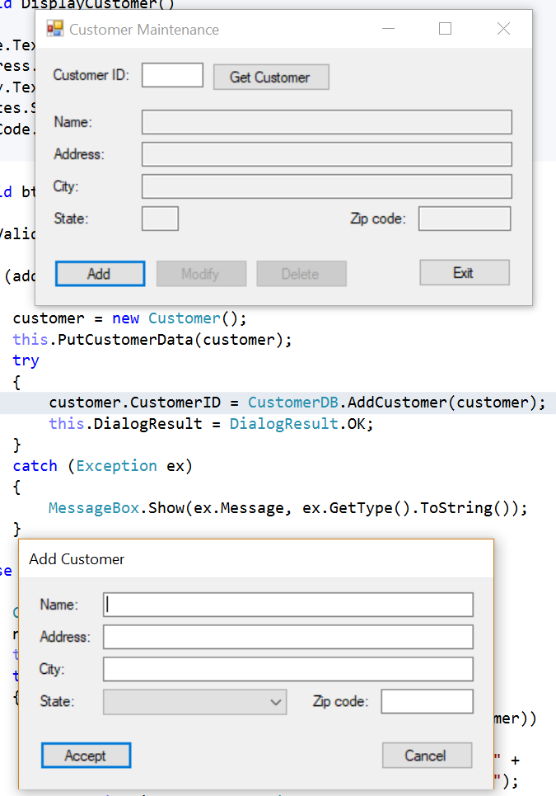

No code added but deleted the comment from the highlighted line in the screenshot.

15. 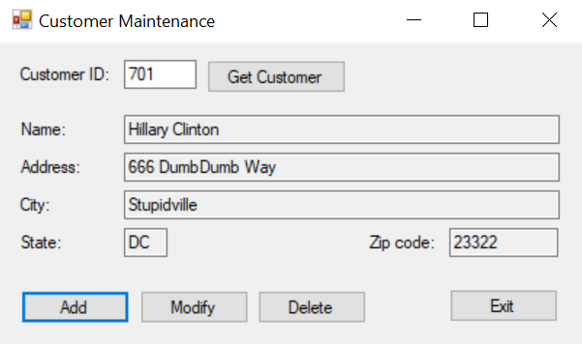

16. 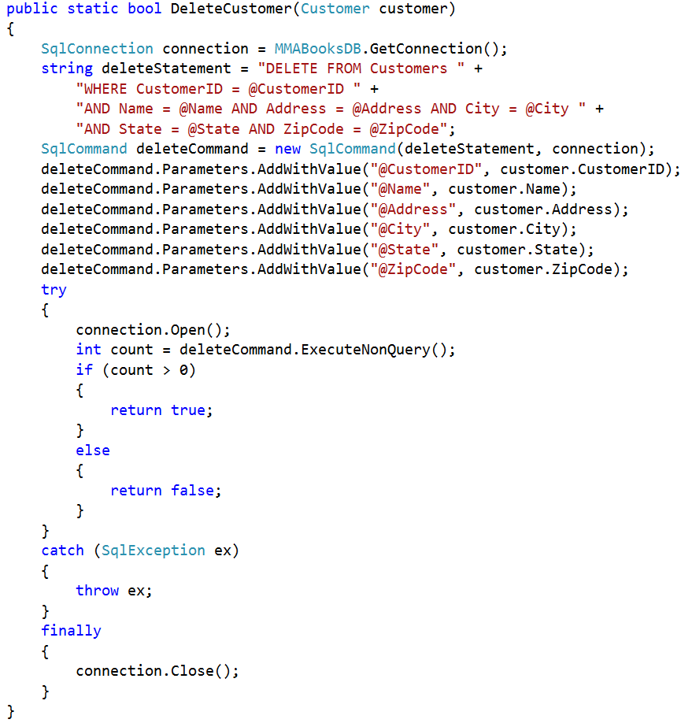

Code added was:

public static bool DeleteCustomer(Customer customer)

{

SqlConnection connection = MMABooksDB.GetConnection();

string deleteStatement = "DELETE FROM Customers " +

"WHERE CustomerID = @CustomerID " +

"AND Name = @Name AND Address = @Address AND City = @City " +

"AND State = @State AND ZipCode = @ZipCode";

SqlCommand deleteCommand = new SqlCommand(deleteStatement, connection);

deleteCommand.Parameters.AddWithValue("@CustomerID", customer.CustomerID);

deleteCommand.Parameters.AddWithValue("@Name", customer.Name);

deleteCommand.Parameters.AddWithValue("@Address", customer.Address);

deleteCommand.Parameters.AddWithValue("@City", customer.City);

deleteCommand.Parameters.AddWithValue("@State", customer.State);

deleteCommand.Parameters.AddWithValue("@ZipCode", customer.ZipCode);

try

{

connection.Open();

int count = deleteCommand.ExecuteNonQuery();

if (count > 0)

{

return true;

}

else

{

return false;

}

}

catch (SqlException ex)

{

throw ex;

}

finally

{

connection.Close();

}

}

17. 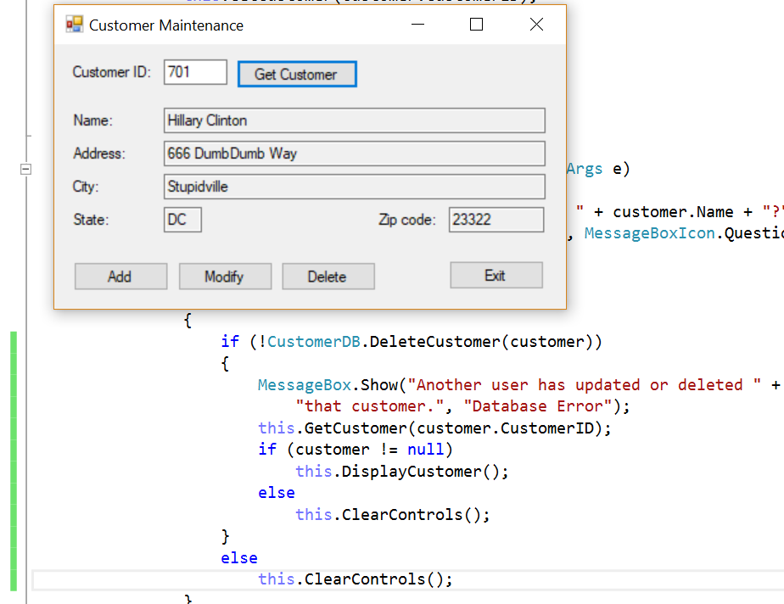

No code added but un-commented section highlighted in green on the left side.

18. 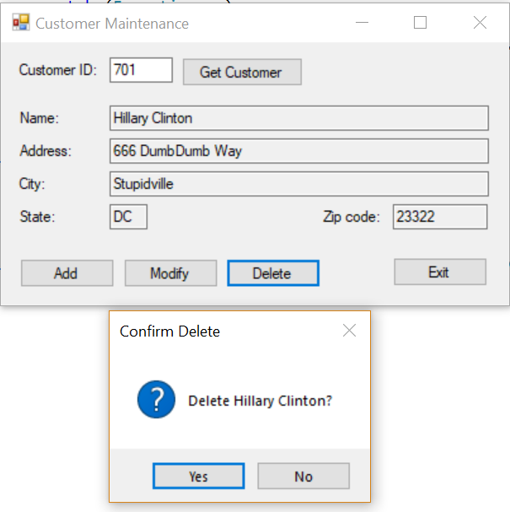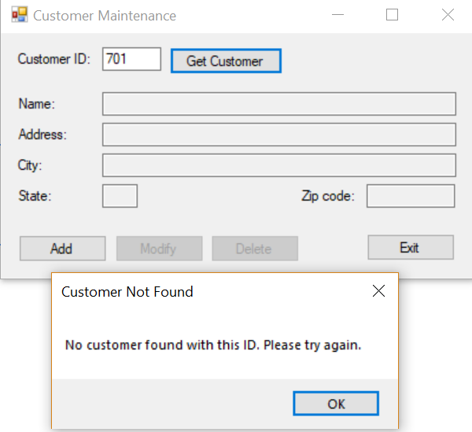

Deleted customer and then the customer ID was not found. So it worked.